OPERATION FALSE ASSURANCE

Team Name | BYEBUST
Phase Number / Title | Phase 2 / OFA P2-04 — Gateway HTTP Request 944
Incident Date | 2025-10-03 (UTC)
Date Submitted | 2026-08-22

REPORT SCORING
No. | Category | Percentage | Points
1 | Executive Summary | 10% | 100
2 | Incident Timeline & Attack Reconstruction | 15% | 150
3 | Victim & Infrastructure Identification | 10% | 100
4 | Technical Investigation, Evidence & Attack Analysis | 55% | 550
5 | Containment, Eradication & Recovery Recommendations | 5% | 50
6 | Report Quality & Professional Presentation | 5% | 50
 | TOTAL | 100% | 1,000
Evidence Requirement: Major findings must be supported by Security Onion, Kibana, Elasticsearch, Zeek, Suricata, or other authorized evidence. Unsupported findings may receive no more than 50% of the available points for that finding.

1. EXECUTIVE SUMMARY
10% - 100 Points
Summarize the activity observed during this phase. State what happened, the affected system, the nature of the malicious activity, and the operational significance.
This report documents a single, focused finding from Operation False Assurance Phase 2: identification of the HTTP method and request URI repeatedly used by infected workstation 10.8.20.101 during its NetSupport Manager remote-access-trojan (RAT) gateway session with 38.146.28.242:1203.
Security Onion Hunt analysis of Zeek HTTP logs (event.dataset:zeek.http) filtered to the gateway IP shows all 48 observed HTTP transactions used the same method and request URI: POST requests to http://38.146.28.242/fakeurl.htm, sent at approximately one-minute intervals for the duration of the session.
This static POST / http://38.146.28.242/fakeurl.htm pattern is the defining network signature of the NetSupport Manager RAT beacon/check-in protocol observed in this incident and provides a high-confidence, repeatable detection indicator.

2. INCIDENT TIMELINE AND ATTACK RECONSTRUCTION
15% - 150 Points
Record the significant events in chronological order. Use UTC for all timestamps.
Date / Time (UTC) | Source | Destination | Protocol / Port | Activity / Observation
2025-10-03 09:48:01-09:56:59 UTC (representative window; 48 events total) | 10.8.20.101 | 38.146.28.242 | TCP/1203 (HTTP) | Repeated identical HTTP transactions: method POST, request URI http://38.146.28.242/fakeurl.htm, at ~60-second intervals (NetSupport Manager RAT beacon/check-in)
2025-10-03 09:56:59.230 UTC | 10.8.20.101:63910 | 38.146.28.242:1203 | TCP/1203 (HTTP) | Most recent captured event: POST http://38.146.28.242/fakeurl.htm; http.useragent = NetSupport Manager/1.3

Attack Reconstruction
Describe how the activity developed during the phase, what the attacker accomplished, and how the available evidence supports the conclusion.
Security Onion Hunt query event.dataset:zeek.http && destination.ip:"38.146.28.242" returned 48 matching HTTP transaction records, all originating from 10.8.20.101:63910 to the NetSupport gateway 38.146.28.242 on TCP/1203 (Figure 1).
Expanding an individual event record shows http.method = POST and http.uri = http://38.146.28.242/fakeurl.htm (Figures 2-3); the http.useragent field confirms the client as "NetSupport Manager/1.3".
Reviewing the Events table in descending time order shows this exact POST http://38.146.28.242/fakeurl.htm transaction repeating at approximately 60-second intervals - e.g. 09:56:59.230, 09:56:02.679, 09:55:02.491, 09:54:02.408 UTC, and so on - consistent with a periodic RAT check-in beacon rather than a one-off request (Figure 1).
All 48 records share identical method, URI, destination IP, and destination port, confirming that POST to http://38.146.28.242/fakeurl.htm is the single, repeatedly-used HTTP request pattern for this gateway session.

3. VICTIM AND INFRASTRUCTURE IDENTIFICATION
10% - 100 Points

Affected System
IP Address | 10.8.20.101
Hostname | Not Determined
User Account | Not Determined
Operating System | Not Determined
Active Directory Domain | Not Determined
System Role | Workstation (per exercise scenario: "Infected Workstation")
Status | Confirmed Compromised - repeated POST http://38.146.28.242/fakeurl.htm beacon confirms an active NetSupport RAT C2 session
Status: Confirmed Compromised / Suspected Compromised / Targeted / Scanned / Not Determined

Relevant Infrastructure
Type | Domain / IP Address | Port | Purpose / Observation
C2 - Remote Access Tool (Domain) | westford-systems.icu | 1203 | Domain observed resolving to the NetSupport gateway IP
C2 - Remote Access Tool (Gateway IP) | 38.146.28.242 | 1203 | NetSupport Manager RAT gateway; resolved answer for westford-systems.icu
Internal DNS Resolver | 10.8.20.1 | 53 | Resolver used by the infected host for the westford-systems.icu lookup

4. TECHNICAL INVESTIGATION, EVIDENCE AND ATTACK ANALYSIS
55% - 550 Points
This section contains the main technical findings. Each significant conclusion should be supported by evidence.

4.1 Analyst Findings
No. | Finding / Objective | Answer / Result | Evidence Ref.
1 | What HTTP method and request URI were repeatedly used during the gateway session? | Method: POST -> Request URI: http://38.146.28.242/fakeurl.htm (identical in all 48 events, ~60s interval) | Figures 1-3

4.2 Malware / Tool Identification
Malware / Tool / Technique | Evidence | Confidence
NetSupport Manager v1.3 (legitimate remote-support tool abused as a RAT) | All 48 zeek.http events to 38.146.28.242:1203 show identical http.method=POST and http.uri=http://38.146.28.242/fakeurl.htm; http.useragent = "NetSupport Manager/1.3" (Figures 1-3) | High
Technical analysis:
The NetSupport Manager RAT client repeatedly issues the identical HTTP request - method POST, request URI http://38.146.28.242/fakeurl.htm - to its gateway on TCP/1203 as a check-in/poll beacon. The static, unchanging URI (rather than a randomized or session-specific path) is characteristic of this RAT's plaintext HTTP transport.

4.3 Network Activity
Time (UTC) | Source IP | Destination IP | Port | Protocol | Domain / Host | Observation
2025-10-03 09:56:59.230 UTC | 10.8.20.101 | 38.146.28.242 | 1203 | HTTP (NetSupport Manager) | 38.146.28.242 (http.virtual_host) | http.method=POST, http.uri=http://38.146.28.242/fakeurl.htm
2025-10-03 09:48:01-09:56:59 UTC (48 events) | 10.8.20.101 | 38.146.28.242 | 1203 | HTTP (NetSupport Manager) | 38.146.28.242 | Same POST /fakeurl.htm request repeated at ~60s cadence across the full session
Analysis:
All 48 zeek.http records for destination.ip 38.146.28.242 share source 10.8.20.101:63910, destination port 1203, http.method POST, and http.uri http://38.146.28.242/fakeurl.htm - a single repeating request pattern with no variation observed across the session (Figure 1).

4.4 Command-and-Control Activity
C2 Domain / IP | Port | Protocol | First Seen | Observation
westford-systems.icu / 38.146.28.242 | 1203 | HTTP (NetSupport Manager) | ~2025-10-03 09:49 UTC (earliest of most-recent 10 of 48 events reviewed) | NetSupport Manager RAT beacon (CMD=POLL, CMD=ENCD) to /fakeurl.htm; gateway IP confirmed via DNS resolution of westford-systems.icu (single A record, no other domains observed resolving to this IP)
Assessment:
The repeated POST http://38.146.28.242/fakeurl.htm request to 38.146.28.242:1203 is the confirmed application-layer C2 beacon for the NetSupport Manager RAT session tied to host 10.8.20.101; its high regularity (~60s cadence) and static URI make it a reliable detection/blocking signature.

4.5 Files and Payloads
Filename | Source / URL | Type | Observation
Use “Not Determined” when the exact filename or content cannot be confirmed from the available evidence.

4.6 Credential Collection / Exfiltration
Collection Method
Information Collected
Exfiltration Method
Destination
Protocol / Port
Assessment:
________________________________________________________________________________
________________________________________________________________________________

4.7 Lateral Movement
Time (UTC) | Source | Destination | Port / Protocol | Activity
State whether the destination was merely contacted, targeted, or confirmed compromised.
________________________________________________________________________________
________________________________________________________________________________

4.8 Ransomware Activity
Ransomware Family
Initial Source
First Target
Propagation Protocol
Destination Port
Exploit / Technique
Additional Propagation Sources
Affected Systems
First Observed Time
Last Observed Time
Assessment:
________________________________________________________________________________
________________________________________________________________________________
________________________________________________________________________________

4.9 Indicators of Compromise
Indicator | Type | Purpose / Assessment | Recommended Action
westford-systems.icu | Domain | Resolves to the NetSupport Manager RAT gateway | Block/sinkhole domain; add to DNS blocklist
38.146.28.242:1203 | C2 IP:Port | NetSupport Manager RAT gateway (resolved from westford-systems.icu) | Block at perimeter firewall/proxy; add to blocklist
POST http://38.146.28.242/fakeurl.htm | HTTP Method + Request URI | Repeated (48x) NetSupport RAT beacon/check-in request to the gateway | Add IDS/EDR signature for this exact method+URI combination; block/alert on repeated POST requests to /fakeurl.htm

4.10 Investigation Evidence
Query / Filter Used: event.dataset:zeek.http && destination.ip:"38.146.28.242"
Security Onion Hunt (Elasticsearch): event.dataset:zeek.http && destination.ip:"38.146.28.242" (time range: last 365 days)
Finding:
All 48 matching HTTP events share identical http.method (POST) and http.uri (http://38.146.28.242/fakeurl.htm) values - confirming this exact request as the one repeatedly used throughout the gateway session (Figures 1-3).

Evidence Reference: Figures 1-3
Kibana / Elasticsearch
Alerts / Suricata
Time (UTC) | Alert | Source | Destination | Remarks
2025-10-03 ~09:48-09:57 UTC (48 events) | ET REMOTE_ACCESS NetSupport Remote Admin Checkin | 10.8.20.101:63910 | 38.146.28.242:1203 | Confirms 48 identical POST http://38.146.28.242/fakeurl.htm requests forming the RAT beacon/check-in channel
Zeek Logs Used
- [x] conn
- [x] dns
- [x] http
- [ ] ssl / tls
- [ ] smtp
- [ ] files
- [ ] dhcp
- [ ] kerberos
- [ ] smb
- [ ] other: Suricata eve.json alerts (imported)
Relevant observation:
Expanding individual zeek.http records confirms http.method: POST and http.uri: http://38.146.28.242/fakeurl.htm on every reviewed event, with http.useragent: NetSupport Manager/1.3 (Figures 2-3).

4.11 Evidence Register
Evidence No. | Description | Source
E-01 | Security Onion Hunt - event.dataset:zeek.http && destination.ip:"38.146.28.242": Events table showing 8 of 48 matching records, all http.method POST to the same destination at ~60-second intervals. | Security Onion
E-02 | Security Onion Hunt - expanded zeek.http event record: http.method field value = POST. | Zeek (via Security Onion)
E-03 | Security Onion Hunt - expanded zeek.http event record: http.uri field value = http://38.146.28.242/fakeurl.htm. | Zeek (via Security Onion)
E-04 | Not applicable to this focused finding. | Zeek
E-05 | Not applicable to this focused finding. | Other
Each screenshot should include a short caption explaining what it shows.

4.12 MITRE ATT&CK Mapping
Tactic | Technique | Technique ID | Evidence
Command and Control | Remote Access Software | T1219 | NetSupport Manager RAT beacon traffic to 38.146.28.242:1203 (Figure 1)
Command and Control | Application Layer Protocol: Web Protocols | T1071.001 | Static, repeated HTTP POST request to http://38.146.28.242/fakeurl.htm used as the RAT check-in beacon (Figures 1-3)
Command and Control | Dynamic Resolution / Domain Fronting Infrastructure (DNS) | T1568 | Gateway IP resolved via attacker-registered domain westford-systems.icu (Figures 2-3)

5. CONTAINMENT, ERADICATION AND RECOVERY
5% - 50 Points
Provide recommendations based on the findings from this phase.

Immediate Actions
1. Add an IDS/EDR signature/alert for HTTP POST requests to the URI /fakeurl.htm directed at 38.146.28.242 (or any host), to detect this RAT beacon pattern.
2. Block/sinkhole 38.146.28.242:1203 at the perimeter firewall and proxy to stop the beacon channel.
3. Correlate this HTTP request pattern with the broader Phase 2 investigation (infected workstation 10.8.20.101 and gateway domain westford-systems.icu).

Additional Recommendations
Network:
Add a firewall/IDS rule matching HTTP POST to /fakeurl.htm; block/sinkhole 38.146.28.242 and any future gateway IPs exhibiting the same request pattern.
Endpoint:
Hunt for NetSupport Manager artifacts (installed software, running processes) on 10.8.20.101 and peer hosts; inspect local traffic for the same POST /fakeurl.htm pattern directed at other destinations.
Accounts / Credentials:
Not applicable to this focused finding.
Active Directory, if applicable:
Not Determined.
Recovery:
See the main Phase 2 investigation report for host-level recovery recommendations.

6. CONCLUSION
Provide the team’s final assessment of the phase. State what happened, what system was affected, what the attacker accomplished, the evidence supporting the conclusion, the impact, and how this phase relates to the larger incident.
This focused investigation confirmed that the NetSupport Manager RAT session between infected workstation 10.8.20.101 and gateway 38.146.28.242:1203 used a single, repeated HTTP request pattern.
All 48 observed HTTP transactions used HTTP method POST and request URI http://38.146.28.242/fakeurl.htm, occurring at approximately 60-second intervals with no variation.
This static method/URI combination is the defining application-layer signature of the RAT beacon/check-in traffic and provides a reliable, low-noise detection and blocking indicator.
This finding supports the broader Phase 2 conclusion that 10.8.20.101 was compromised and actively used for attacker remote access via NetSupport Manager.
This finding should be read alongside the main Phase 2 report and the companion OFA P2-03 report (gateway domain identification).

7. EVIDENCE LIMITATIONS
List any information that could not be confirmed from the available data. Do not present assumptions as confirmed facts.
The exact start time of the 48-event NetSupport beacon session and full first/last-seen timestamps were not independently re-verified beyond the most recent events reviewed in this pass; see the main Phase 2 report for the broader timeline.
Whether the RAT gateway supports additional request paths or methods beyond POST /fakeurl.htm (e.g. for payload delivery or configuration updates) was not investigated in this pass.

8. APPENDICES

Appendix A - Investigation Queries
Query:
Query 1: event.dataset:zeek.http && destination.ip:"38.146.28.242" (Security Onion Hunt, Last 365 days) - returns all 48 HTTP transactions to the NetSupport gateway.
Query:
Query 2: Expand any single event -> inspect fields http.method and http.uri (Security Onion Hunt event detail view) - confirms POST and http://38.146.28.242/fakeurl.htm.
Query:
Query 3: event.dataset:zeek.http && destination.ip:"38.146.28.242" | groupby http.method http.uri (Security Onion Hunt) - groups all 48 events by method/URI to confirm no variation across the session.

Appendix B - Figures and Screenshots
Use sequential figure numbers. Each figure should include a short caption describing what the evidence demonstrates.
Figure 1
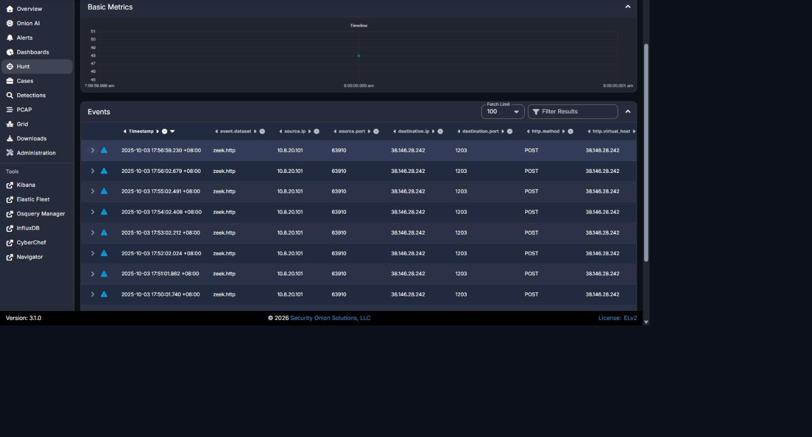
Security Onion Hunt - event.dataset:zeek.http && destination.ip:"38.146.28.242": Events table (8 of 48 shown) - every record shows http.method POST, repeating at ~60-second intervals.
Figure 2
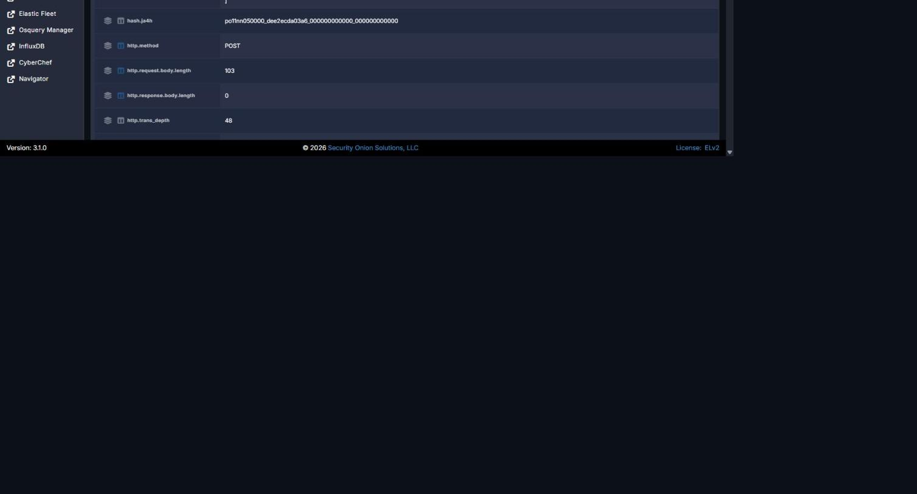
Security Onion Hunt - expanded zeek.http event record: http.method field value = POST.
Figure 3
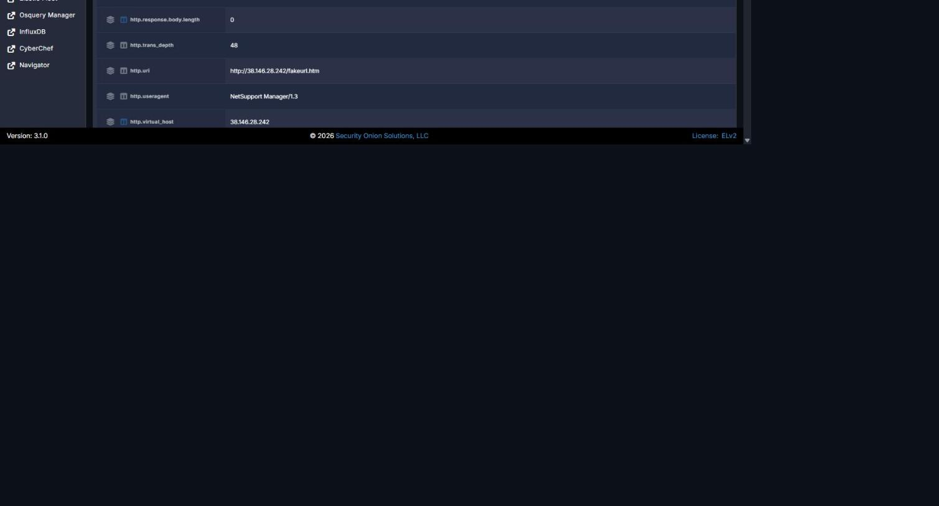
Security Onion Hunt - expanded zeek.http event record: http.uri field value = http://38.146.28.242/fakeurl.htm.
Figure | Caption / Description
Figure 1 | Security Onion Hunt - event.dataset:zeek.http && destination.ip:"38.146.28.242": Events table (8 of 48 shown) - every record shows http.method POST, repeating at ~60-second intervals.
Figure 2 | Security Onion Hunt - expanded zeek.http event record: http.method = POST.
Figure 3 | Security Onion Hunt - expanded zeek.http event record: http.uri = http://38.146.28.242/fakeurl.htm.

REPORT QUALITY REQUIREMENTS
5% - 50 Points
- Clear and logical organization
- Correct technical terminology
- Accurate use of timestamps
- Readable screenshots
- Properly labeled tables and figures
- Consistent evidence references
- Clear distinction between confirmed facts and analyst inference
- Professional presentation and readability

SUBMISSION INSTRUCTIONS
1. Submit one report for each phase designated as Report-Required.
2. Submit the final report in PDF format unless otherwise directed.
3. Clearly indicate the team name, phase number, and phase title.
4. Use UTC for timestamps.
5. Major findings must be supported by evidence.
6. Screenshots must be numbered and captioned.
7. Do not include executable malware samples in the report.
8. State 'Not Determined' when a finding cannot be confirmed.
9. Ensure all screenshots, tables, and text are readable.
10. Reports must be submitted before the deadline announced by exercise control.
Evidence Rule: A correct finding without supporting Security Onion, Kibana, Elasticsearch, Zeek, Suricata, or other authorized evidence may receive no more than 50% of the points assigned to that finding. Incorrect or fabricated evidence receives zero points for the affected finding.

